**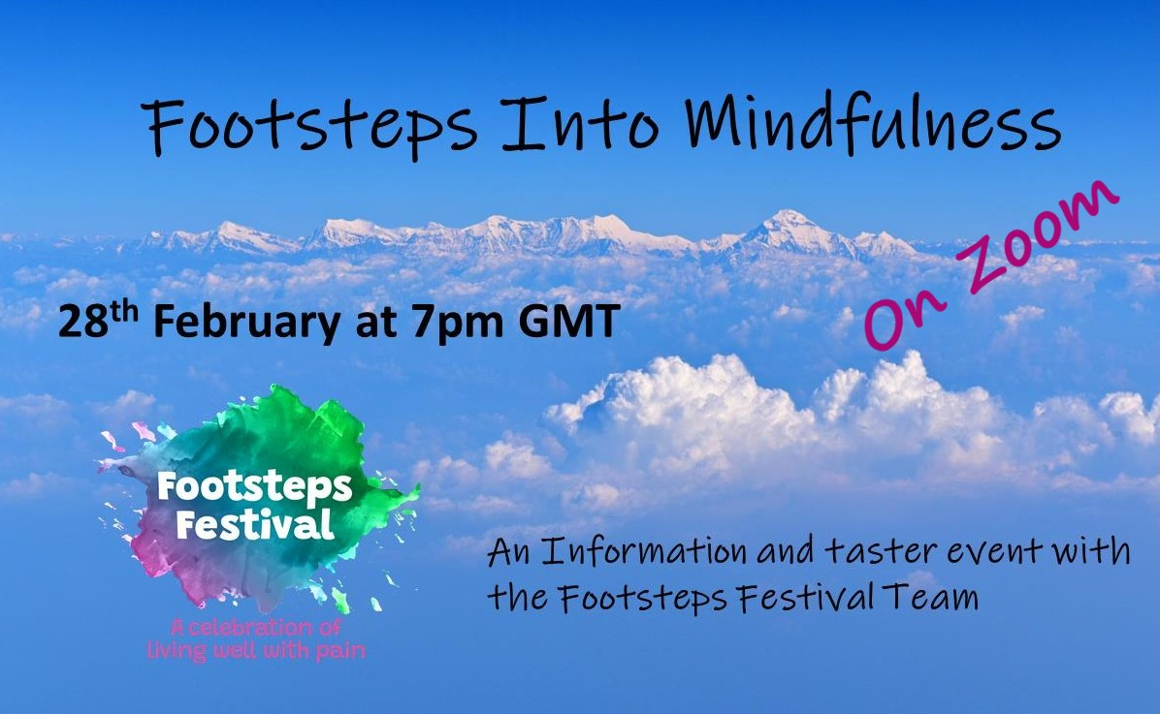**

**Mindfulness Resources**

Thank you for joining us at Footsteps into Mindfulness with the Footsteps Festival Team – we were delighted to see you. For those for whom life intervened and were not able to join us live, and for anyone wanting a reminder, the Event is available on our YouTube channel via the link below.

<https://youtu.be/81u2y0U5OS8>

The Footsteps Festival is offering an 8 week Mindfulness Based Stress Reduction (MBSR) course for its subscribers run by Diarmuid Denenny who was part of the team today. Places are limited so please check out the information at the link below**.**

[**https://my.livewellwithpain.co.uk/festival/main-stage/mindfulness-based-stress-reduction-programme-mbsr/**](https://my.livewellwithpain.co.uk/festival/main-stage/mindfulness-based-stress-reduction-programme-mbsr/)

**Help keep Footsteps Festival free**

**We are determined to keep our events free at the point of use so no-one is excluded. All our Team are volunteers and donate their time for free, and we are very grateful to be supported by Live Well With Pain and the Physiotherapy Pain Association. However we do have costs to bear and we are very much grateful for any donation, of whatever size that supports our work. So if you have gained any benefit from our work, please do consider a “Pay as you Feel” donation. If financial support isn’t an option, and we understand how tough times are, you can still make a big impact by sharing our events on Social Media, telling your Health Care Professionals and friends and family – word of mouth is still the mightiest!**

**Many Thanks!**

**Donate here:**

**https://www.justgiving.com/crowdfunding/footsteps-festival**

**Free resources from Today’s presenters:**

* <https://www.newellbeing.co.uk/>audio-exercises

**Shorter mindfulness practices:**

* Mindfulness of breath: <https://soundcloud.com/diarmuiddenneny/mindfulness-of-breath-short-practice/s-xHyD5>
* *3 step breathing space* meditation: <https://soundcloud.com/diarmuiddenneny/3-step-breathing-space-m4a/s-TX101>
* Mountain Meditation: <https://soundcloud.com/diarmuiddenneny/mountain-meditation/s-TU4adCbpK0E>

**Longer meditations:**

* The body scan: <https://soundcloud.com/diarmuiddenneny/body-scan/s-xsDyB>
* Mindfulness of breathing and sitting: <https://soundcloud.com/diarmuiddenneny/mindfulness-of-breathing-dd-mp3/s-QfDXC>
* Mindful Movement: <https://soundcloud.com/diarmuiddenneny/mindfulness-of-movement-dd-mp3/s-HG6sn>
* Turning towards difficulty: <https://soundcloud.com/diarmuiddenneny/turning-towards-difficulty-m4a/s-wmTek>

**External Resources**

Please be aware that while there are many free resources available, many people/organisations are also trying to sell something, so proceed with caution and awareness. These are suggestions and don’t necessarily constitute recommendations. Different types of mediations will appeal to different people; have fun finding what rings your Bell!

**Websites and Personalities**

* **Jon Kabat-Zinn**-The father of modern mindfulness, there are a lot of resources and information here.

<https://www.mindfulnesscds.com/>

* **Tara Brach**- Free resources as well as links to paid books/content.

<https://www.tarabrach.com/guided-meditations/>

* **Rick Hanson** - neuroscientist and proponent of meditations. Free resources as well as links to paid books/content.

<https://www.rickhanson.net/practices-for-growing-an-unshakable-core/>

* **Kristin Neff PhD** -The Self compassion Guru. Lots of free content and free guided meditations.

<https://self-compassion.org/>

<https://self-compassion.org/category/exercises/#guided-meditations>

* **The Zen Master** **[Thich Nhat Hanh](https://plumvillage.org/?page_id=7703" \t "_blank).** (who sadly passed away recently)

<https://plumvillage.org/>

* **Oxford Mindfulness Centre**

<https://www.oxfordmindfulness.org/free-online-mindfulness-course-sessions/>

* **Bangor Centre for Mindfulness Research and Practice**

<https://www.bangor.ac.uk/mindfulness/audio/index.php.en>

* **Breathworks**

<https://www.breathworks-mindfulness.org.uk/free-meditations>

Please see the Footsteps Festival events run with Breathworks and Stanter Kandola. Videos of these informative events are included on the page below;

<https://my.livewellwithpain.co.uk/festival/main-stage/an-introduction-to-breathworks-mindfulness-with-stanter-kandola/>

* **Free Mindfulness**

<http://www.freemindfulness.org/download>

**Podcasts**

Far too many to name! Have a play around and find one that encourages you. They are on Spotify, Apple Podcasts, Android podasts and Audible to name a few.

This is an article outlining some popular mindfulness podcasts:

<https://www.verywellmind.com/best-meditation-podcasts-4771686>

**Apps. (free)**

* **Insight Timer**, 1000’s of free guided meditations and unguided timers with bells etc. There is a paid upgrade but it’s a huge resource even for free. Experiment and find your favourites.
* **Smiling Mind**
* **10% Happier**

**Paid Apps** (most have free trials which you can take advantage of to see if they suit, also the reviews can be useful)

* **Calm** you can get a 7 day or longer free trial (has good and growing selection of sleep stories as well, at least three choices of daily meditations and many themes and short courses on meditation for various topics)
* **Headspace**has some free content or a free trial.
* **Balance** (currently may have a year free but is a reoccurring subscription sells itself as a more bespoke meditation experience which adapts to you)

This is an article outlining some popular mindfulness apps for 2022:

<https://www.goodhousekeeping.com/health/wellness/g31945544/best-meditation-apps/>

If you have an **Audible** subscription there are various books and resources such as podcasts worth exploring.

**YouTube** and **Spotify** have a lot of resources but care must be taken.

**Books**

“Full Catastrophe Living, Revised Edition: How to cope with stress, pain and illness using mindfulness meditation” - Jon Kabat-Zinn

<https://www.amazon.co.uk/Full-Catastrophe-Living-Revised-mindfulness/dp/0749958413>

The other issue is also available and in audiobook form as well, and cheaper 2nd hand copies

[**https://www.amazon.co.uk/Full-Catastrophe-Living-Wisdom-Illness/dp/0345536932/ref=pd\_sbs\_6/258-8551852-5083713?pd\_rd\_w=N0Pel&pf\_rd\_p=c07415a0-09a7-4604-aaca-c3fcee246443&pf\_rd\_r=R0NPXMH2BRBY9JTXSJ1N&pd\_rd\_r=f56dbbad-2574-428b-a27a-34111b0cebff&pd\_rd\_wg=BJGIJ&pd\_rd\_i=0345536932&psc=1**](https://www.amazon.co.uk/Full-Catastrophe-Living-Wisdom-Illness/dp/0345536932/ref=pd_sbs_6/258-8551852-5083713?pd_rd_w=N0Pel&pf_rd_p=c07415a0-09a7-4604-aaca-c3fcee246443&pf_rd_r=R0NPXMH2BRBY9JTXSJ1N&pd_rd_r=f56dbbad-2574-428b-a27a-34111b0cebff&pd_rd_wg=BJGIJ&pd_rd_i=0345536932&psc=1)

Many other books on Mindfulness are available – have fun looking!

Niki R Jones © 2022

